Assembly guide for PICA shield
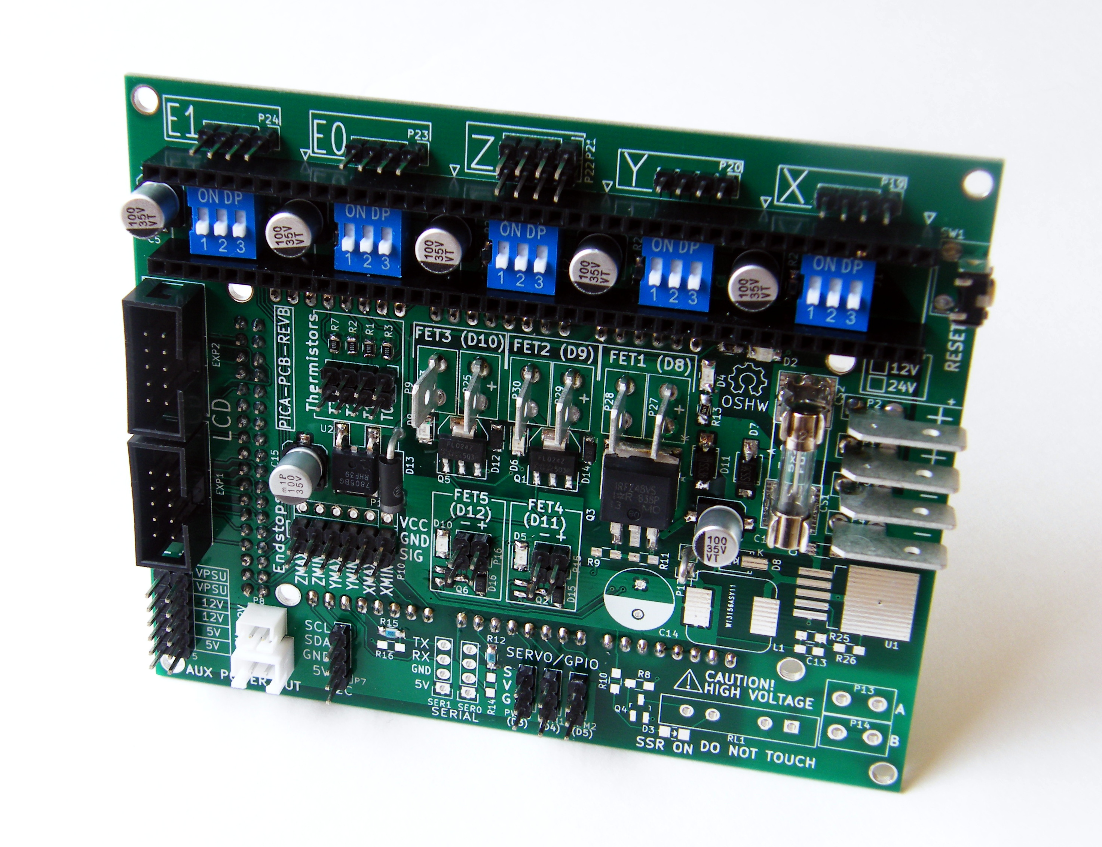
Assembling the PICA shield involves both SMT (surface mount) and through-hole soldering. It is best to begin with the SMT components, as some of the larger parts can make it difficult to get to some of the smaller ones.

1. 4.7K resistors (0805) R13, R20, R21, R22, R23, R24, R14, R16, R4, R1, R2, R3, R7

These are located on the top side of the circuitboard:
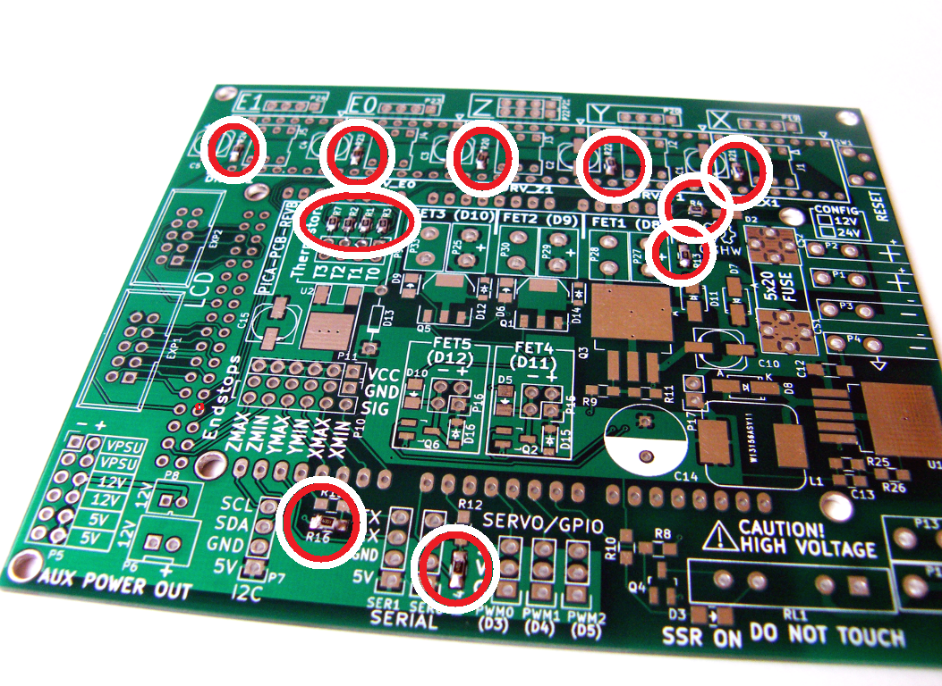
2. LEDs D2, D3, D4, D5, D6, D9, D10
You can use whatever color of LEDs you like. I am using a Green LED for D2 (power) and Red or Yellow for the others. These are standard 1206 SMT LEDs. There is a small green mark on the top of the device to indicate the cathode (-) side of the part.
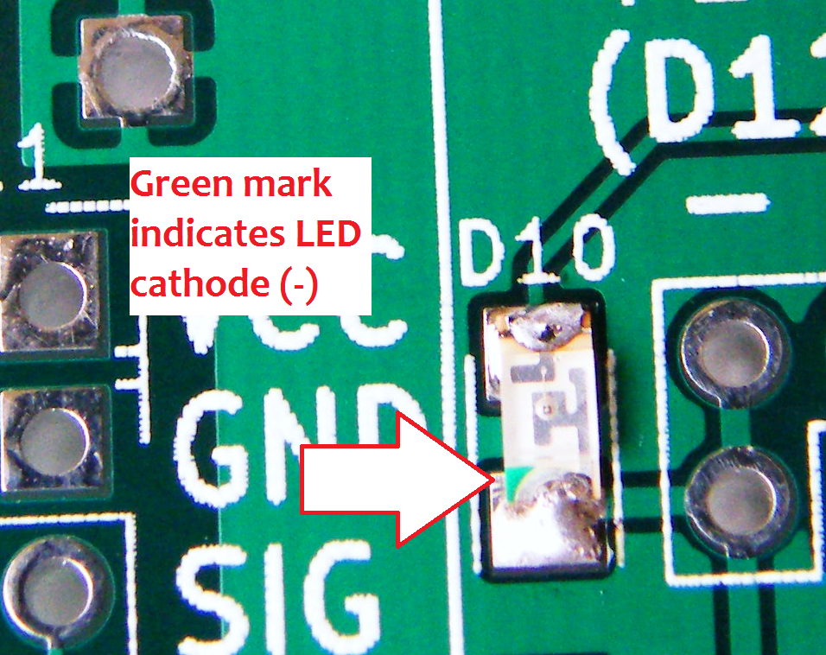
D3 is only used for indicating the SSR on/off so if you won't be installing the SSR you can skip D3.
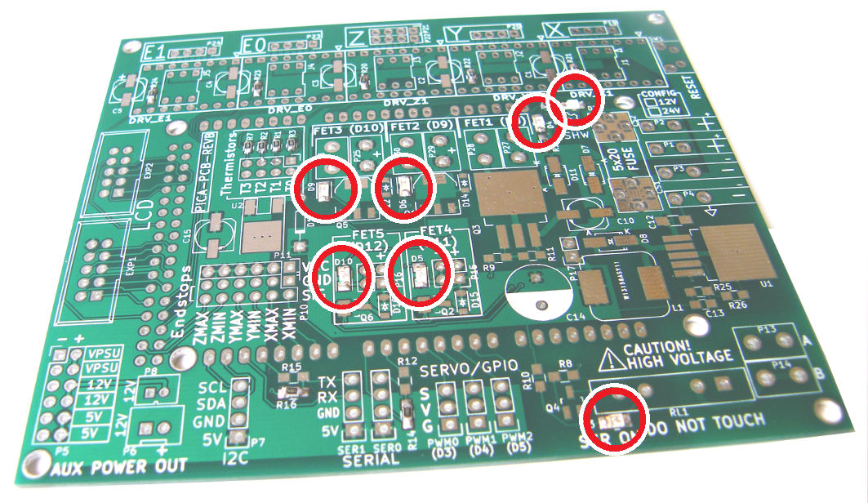
3. Resistor packs
The resistor packs can be oriented in either direction and are located on the back side of the circuitboard. Be careful not to bridge the resistors with too much solder. If you do, use solder wick or a desoldering tool to remove the excess solder.
- RP1, 33 Ohm resistor pack (“330”)
- RP2, 150K Ohm resistor pack (“154”)
- RP3, 3.3K Ohm resistor pack (“332”)

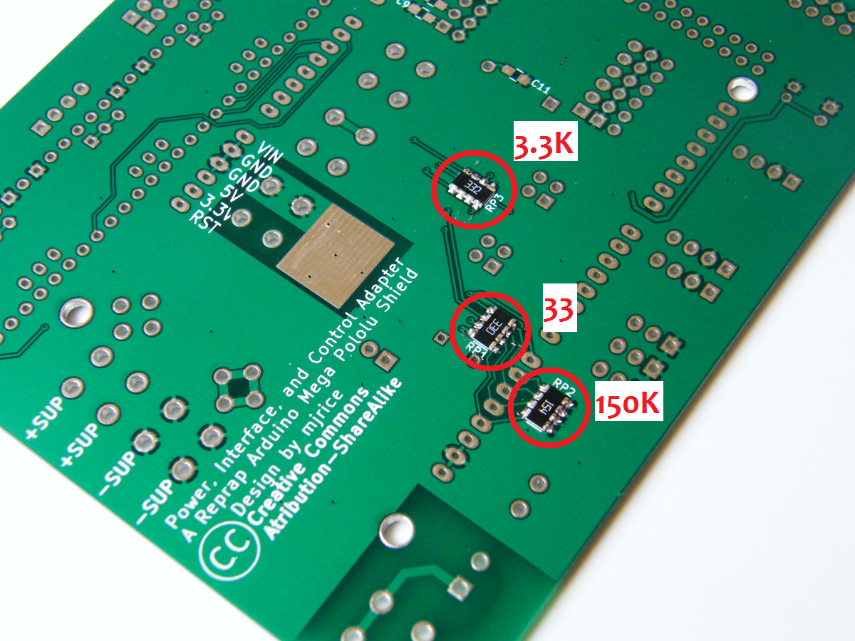
4. .1uF capacitors C6, C7, C8, C9, C11, C12
These can be oriented in either direction. All except C12 are found on the back side of the board.
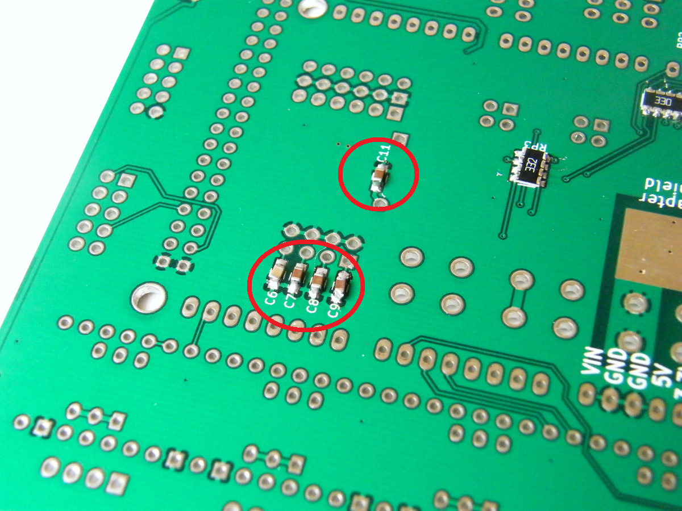

5. 2K resistors R26, R10, R12, R15
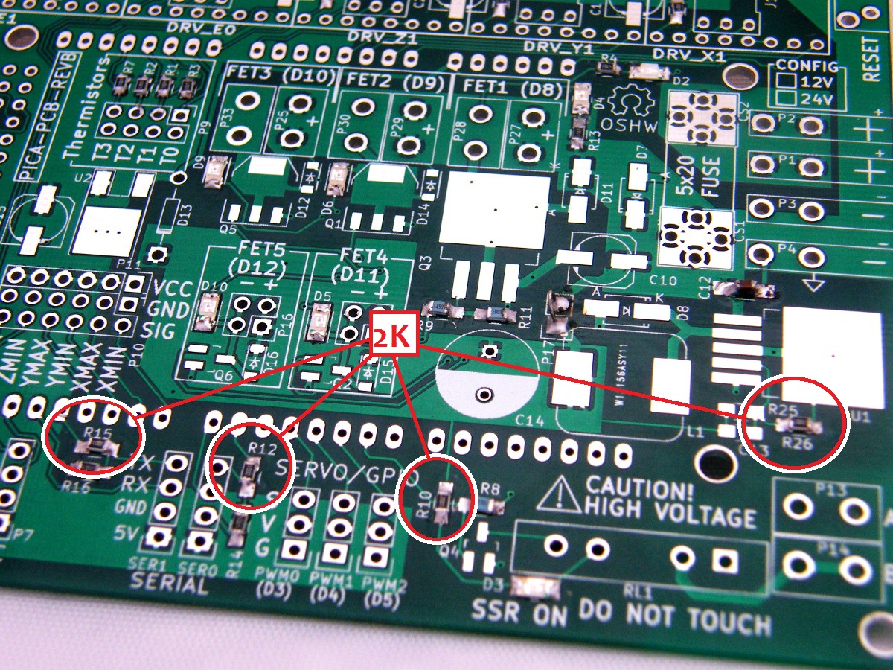
6. 100K resistors R11, R8
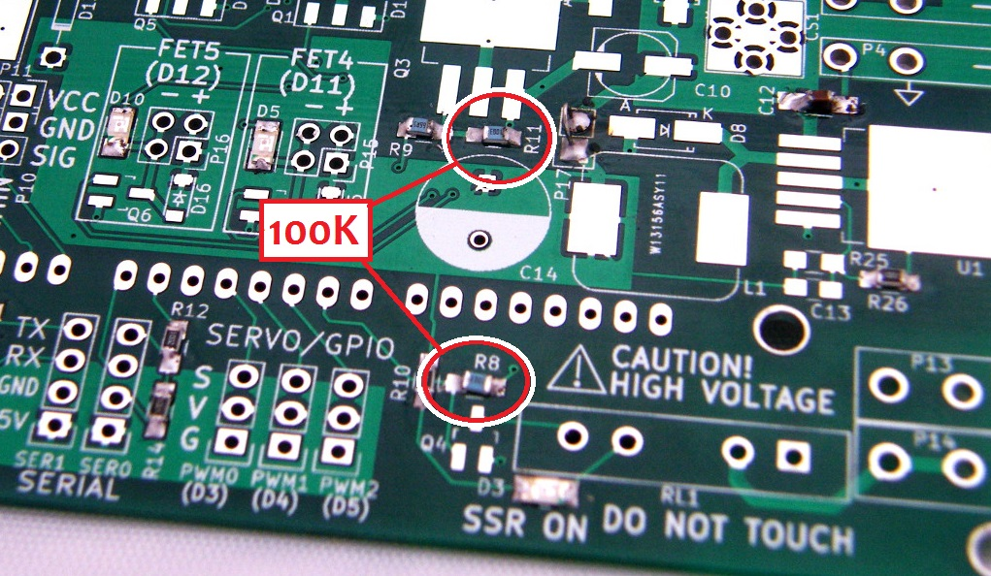
7. 10 Ohm resistor R9
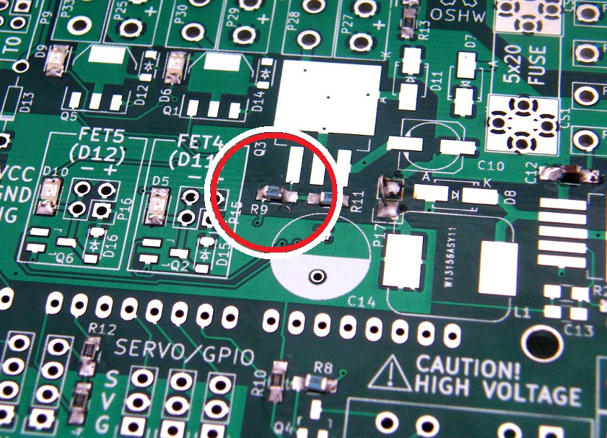
8. Schottky diodes D16, D12, D15, D14
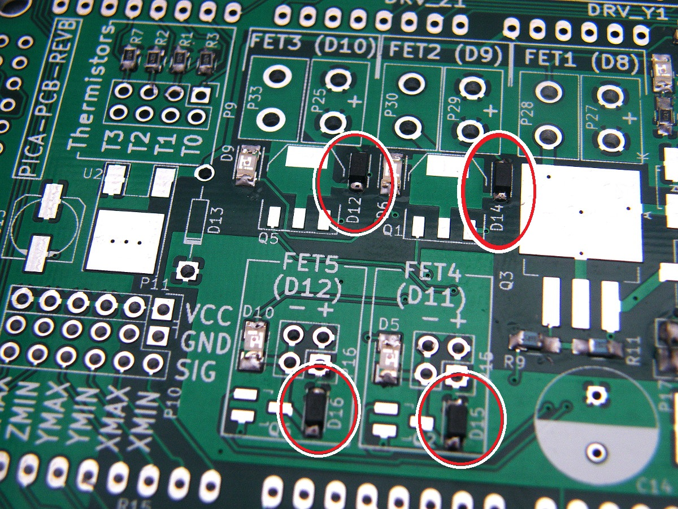
All of the diodes used on the board have a small line printed on top of the part that must align with the cathode side as illustrated on the board's silkscreen.

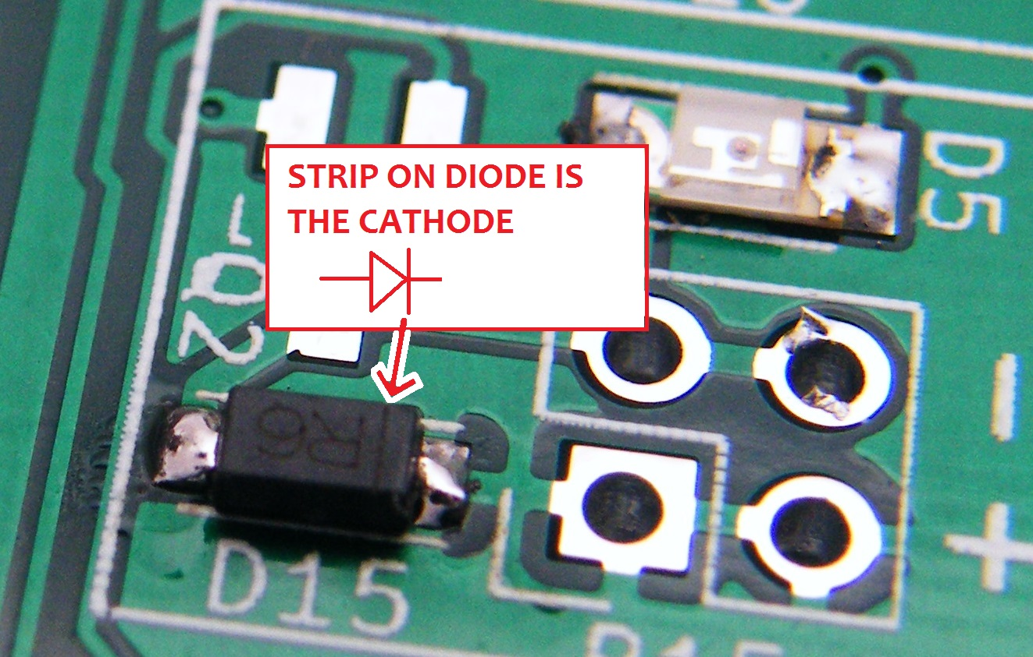
9. Schottky diodes D7, D11
These are the two larger diodes located near the power inlets. They also have a mark indicating the negative (cathode) side which should line up with the mark on the circuitboard.

10. SOT-23 transistors Q2, Q4, Q6
Be sure to ground yourself when handling any of the semiconductors, to prevent ESD damage to the parts!

Q4 is only used for turning the SSR on/off so if you won't be installing the SSR you can skip Q4.

11. SOT-223 transistors Q1, Q5
To hand solder the larger transistors (Q1, Q5, and Q3), heat the large pad with your soldering iron and apply a small bit of solder, then put the transistor in place and continue to heat until the solder “reflows” to the part. Then align the part and let cool before soldering the other pins. It is important that the large pad of the device heats up enough to flow the solder in order to ensure a good electrical and thermal connection to the board.
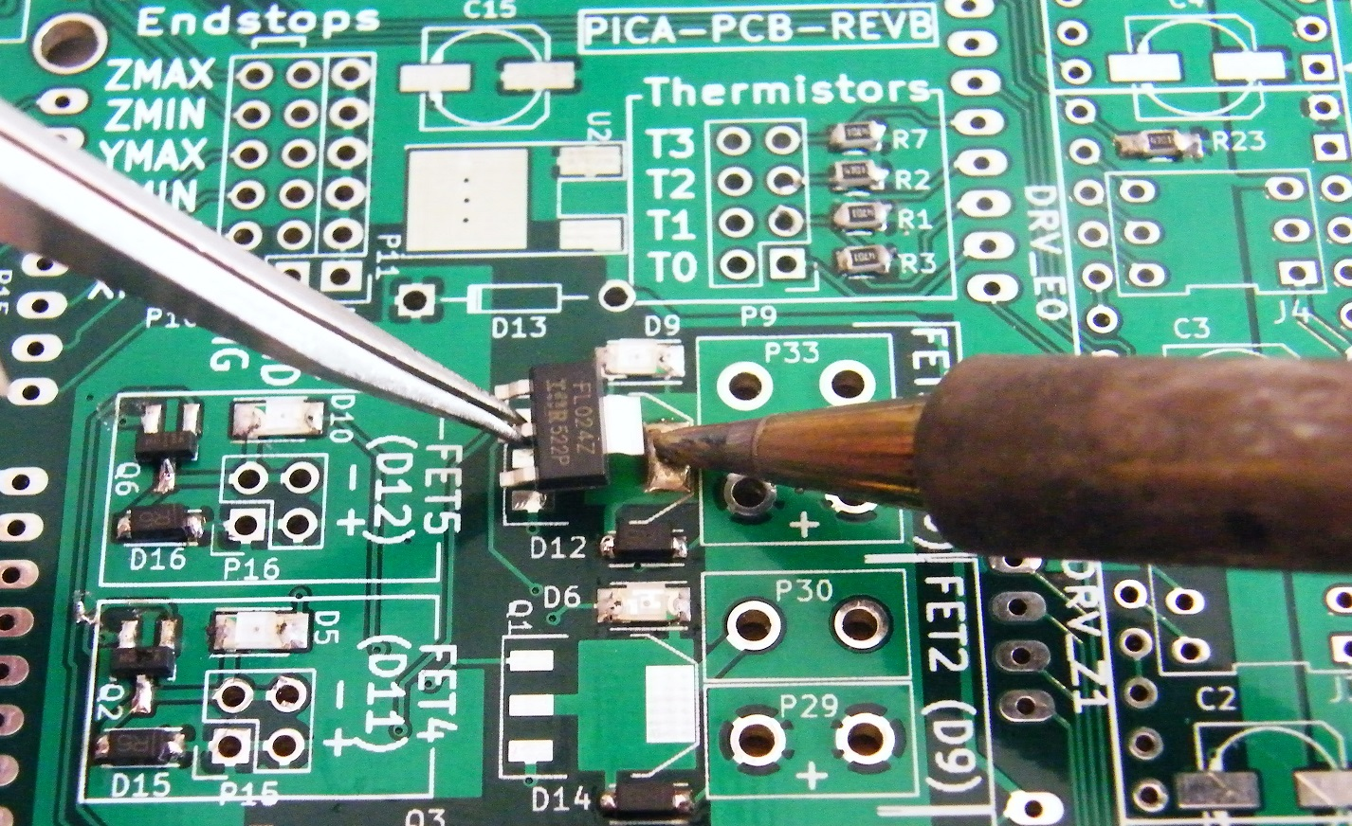
12. TO-263 transistor Q3
Install the larger MOSFET in the same way, being sure not to use too much solder.

13. Voltage regulator U2
Use a similar technique with U2 as you did with the transistor packages.
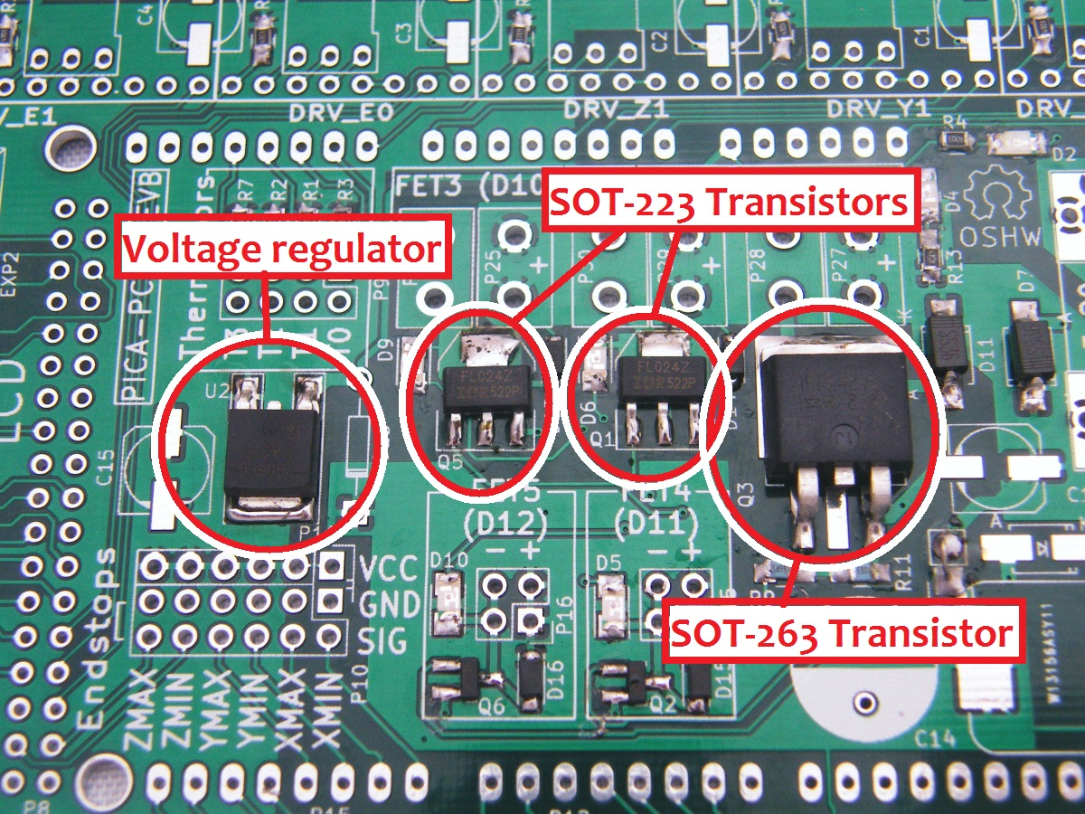

14. 100uF electrolytic capacitors C10,C15,C1,C2,C3,C4,C5
Be sure to orient the electrolytic capacitors properly, or they will go up in smoke when you power on the board. There is a small indent in the silkscreen that aligns with the body of the part, as well as a “+” symbol next to the pad corresponding to the positive side of the component.
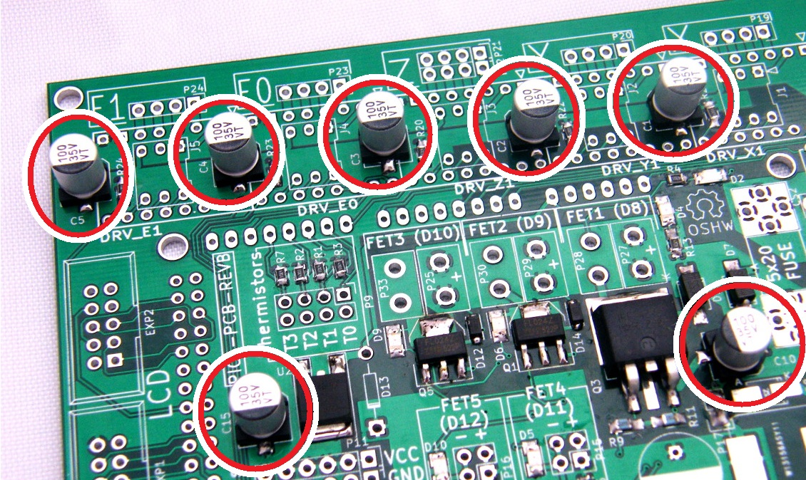

15. DIP Switches, J1,J2,J3,J4,J5
The DIP switches can be oriented either way around.
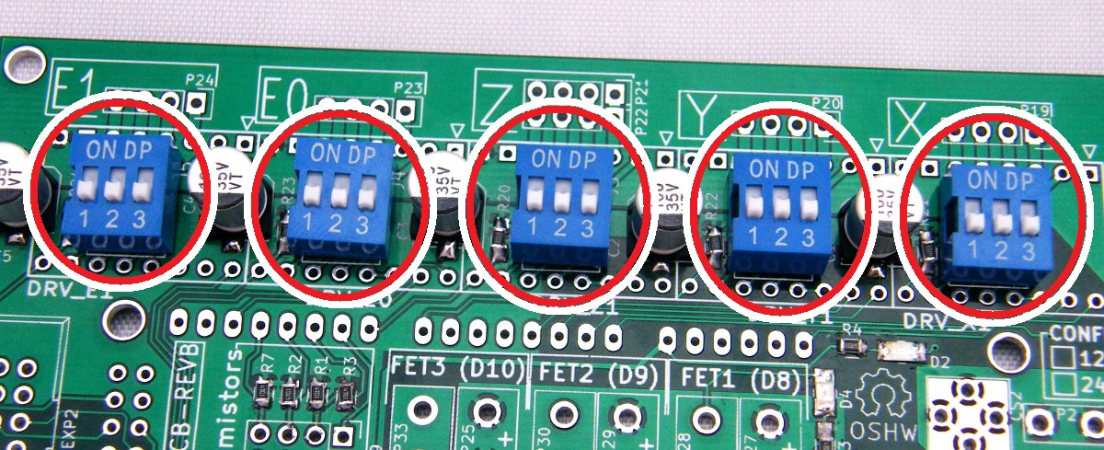
16. 2.54mm female headers for Pololu stepper drivers
Install two 1x40pin female headers to accommodate the five Pololu stepper motor drivers.

17. LCD connectors EXP1, EXP2
Orient the LCD connectors with the notch for the cable header inward as indicated by the silkscreen for EXP1 and EXP2.
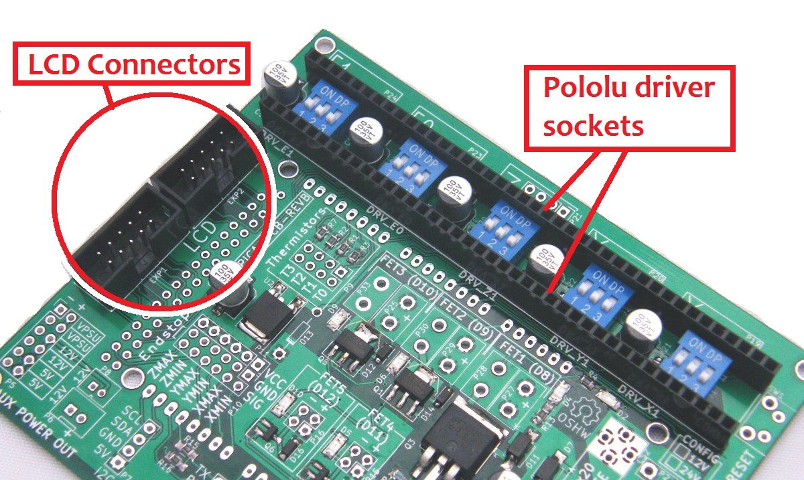

18. Fuse clips CS1, CS2
Orient the two fuse clips so that the backstops are to the outside.
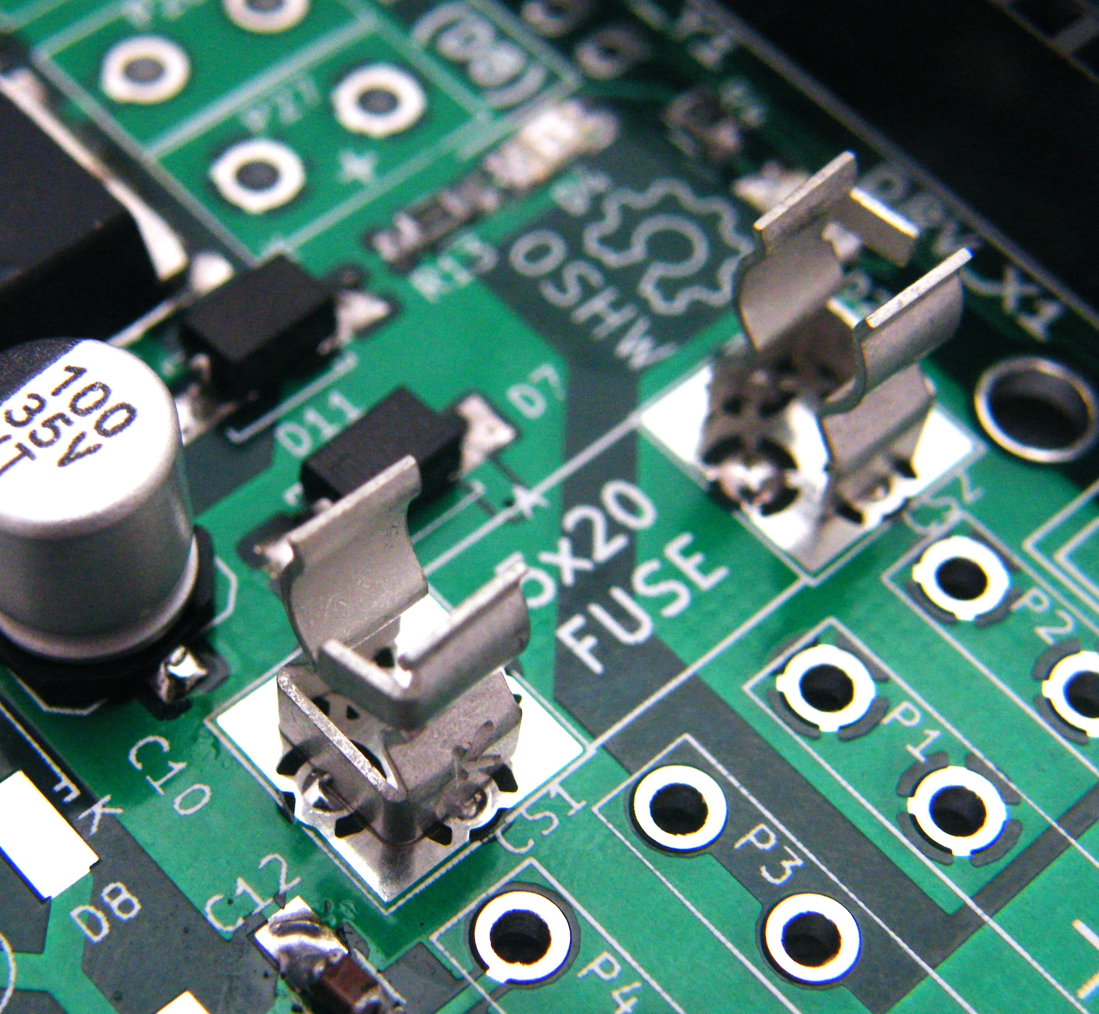
19. Reset switch SW1

20. Bottom-side pin headers (Mega shield connections)

The pin headers come in standard lengths such as 40 pins that you can snap apart to fit each position on the board. Some locations (with (2) next to them below) can be fitted with either 2 single-row headers side-by-side, or a single 2-row header if available.

21. Top side pin headers

Don't install P11 unless your endstops are the 3-pin variety – it is not normally used and presents a risk of shorting your power supply if you mis-align the common 2-pin end stop connector so I don't usually put them in.

6 pin locations: P10(2), P5(2), P11 (optional)
4 pin locations: P7,P19,P20,P21,P22,P23,P24, P9(2)
3 pin locations: PWM0, PWM1, PWM2
2 pin locations: P15(2), P16(2)

22. Serial expansion headers SER0, SER1
You can install male headers or female sockets for connecting to either of the serial port expansions on the PICA shield. I am using female connectors as shown.
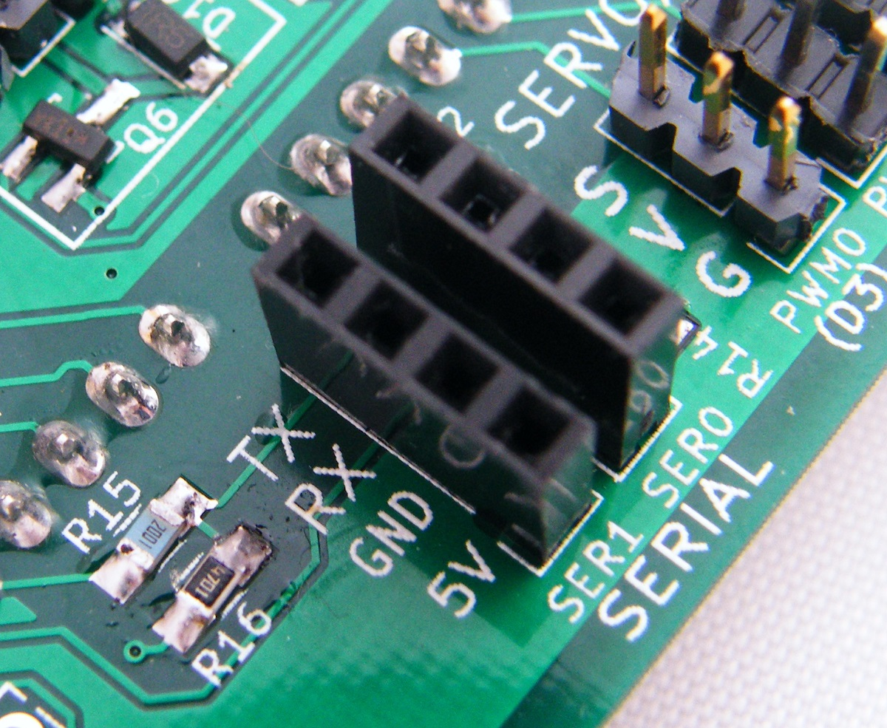
23. Power jumper P17 (12V systems)
Install a wire jumper in P17 (this connects the input power to the 12V power net and is only done on boards assembled for 12V power supplies, so skip this if you are going to fit the board with the 24V to 12V buck regulator).
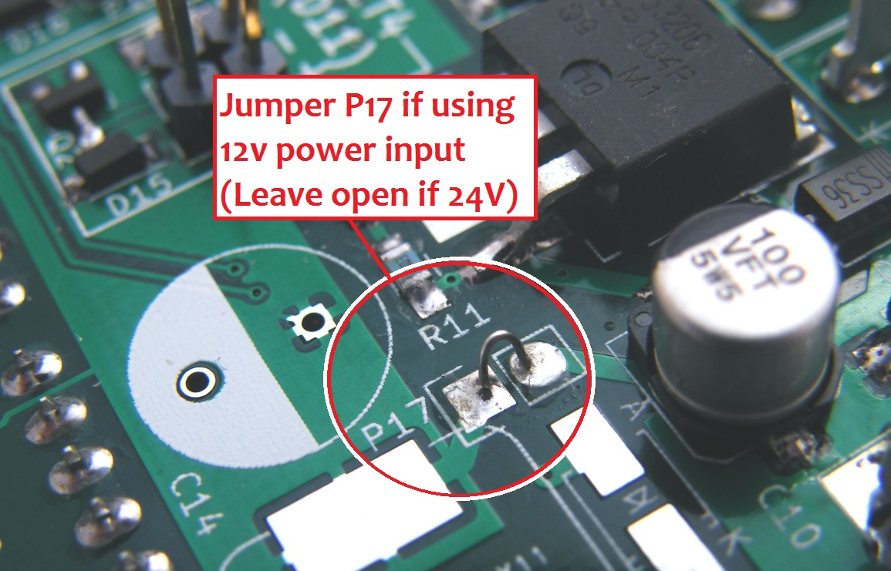
24. JST power connectors P6, P8
There is a keying indicator on the board to show how to orient the JST connectors (the open notch should go toward the lower edge of the circuitboard).
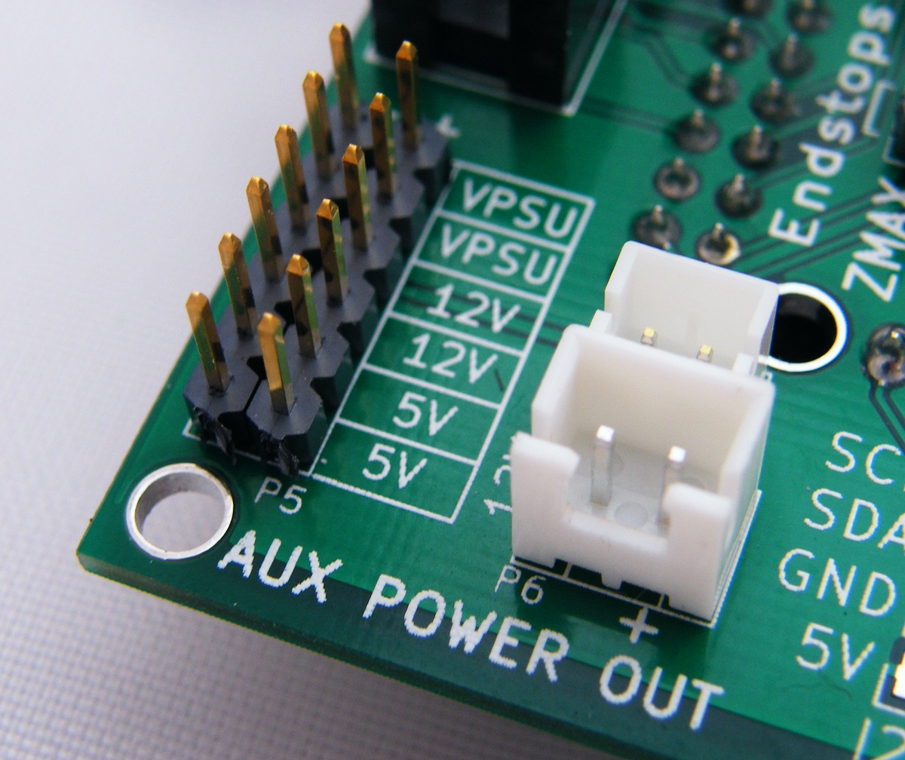
25. Power connectors
- Straight (vertical connection) P28, P27, P29, P30, P25, P33, P13, P14
- Right angle (horizontal connection) P2, P1, P3, P4

It is easier to solder the power connectors from the top side. P13 and P14 are used to connect to the SSR circuit, so if you are not using that you can omit those connectors as well.

26. Zener diode D13
Leave the zener diode about 0.3” above the board, this is to help it cool through convection. Be sure to orient the zener with the striped end as outlined on the circuitboard.
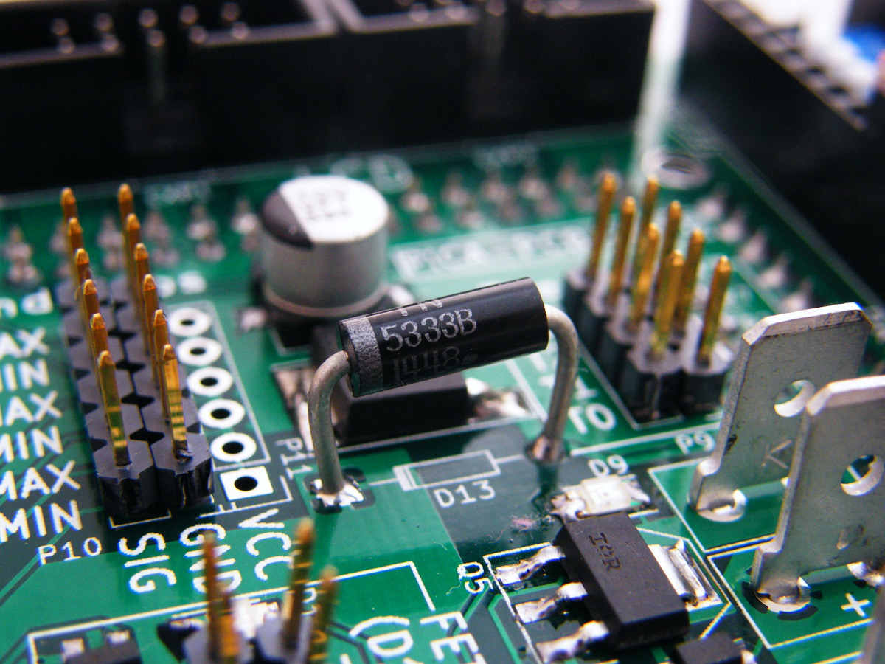

Additional Notes

When installing the stepper motor drivers, orient them so that the adjustment potentiometers are toward the side of the board with the reset switch.


